Postman Assignment 04 - Creating Pre-request Scripts

Learning Objects
- Learn how to use pre-request to set/get variables, so that you can share data between tests;
- Use them to build a request workflow where you can chain multiple test together;

Target API
Star Wars API: https://swapi.dev/

Pre-request introduction
Pre-request scripts work in much the same way that tests do in Postman. These scripts use JavaScript to send commands just like the response assertions but, as the name implies, they are run before the request is sent rather than after. Now, why would you want to do that?
Pre-request scripts are to be used in a couple of different ways:
- When you wanted to test something in an API that required sending multiple API calls. In order to check the things, you needed to be able to pass data that came back from one call into the next call. You could do this by assigning values to variables in the Tests section of the first request and then reading in those variable's values in the next test. However, there were times when you wanted to take one of the variable values and modify it slightly (for example, add one to it) before using it. In that case, a pre-request script can be used to do that.
- Generate a random number or string in a pre-request script and then use that value in the test itself.
- Read or set environment variables.

Using variables in pre-request scripts
You create and use variables in the user interface. Postman also lets you use variables in scripts. You can use them in test scripts as well as pre-request scripts, but for now, I will focus on using them in Pre-request Script tab. The best way to learn this is with a couple of examples. For the first one, create a new request in the SWAPI collection called Get a Person and then use the following steps to create a pre-request script:
- Set the URL of the request to {{base_url}}/people/{{person_id}}.
The base_url variable should already be defined but the person_id variable will not yet be defined.
- Go to the Pre-request Script tab for the request.
- In the Snippets section, click on the Set an environment variable snippet. This will add the following code to the pre-request script:
pm.environment.set("variable_key", "variable_value");
- In the set command, change variable_key to be person_id and change variable_value to be 1.
Now if you send the command, the pre-request script will first set the person_id variable to have a value of 1 and then when the request is sent, it can use that variable in to set the URL correctly.
This example was a simple and somewhat contrived one. I did this in order to help you understand how this works, but there is a lot more that you can do with this. For the next example, we'll look at how to pass data between tests.

Passing data between tests
In order to pass data between requests, you will need multiple requests. You can use the request from the previous example for one of the requests but you will need to create a new request called Get Homeworld in the Star Wars collection. Once you've done that, use the following steps to set up that request and pass data between the two requests:
- Set the URL of that request be {{base_url}}/planets/1.
- On the Tests tab of that request, add the following code:
var jsonData = pm.response.json();
var planetResidents = jsonData.residents;
pm.collectionVariables.set("residentList", planetResidents);
This will get the list of URLs that represent the people who live on this planet out of the response from the first request and add it to a variable called residentList. Note that in this case, we are saving the variable into the collectionVariables scope. That is so that it will be available to all requests in the collection.
- Send the Get Homeworld request in order to create that variable.
Now that you have a variable with a list of URLs, let's see if you can use it in the Get a Person request to get the information about one of the residents of that planet.
- On the Pre-request Script tab of the Get a Person request, get rid of the previous code and instead add the following code:
var residentList = pm.collectionVariables.get('residentList');
var randomResident = residentList[Math.floor(Math.random() * residentList.length)];
var splitResidentStr = randomResident.split('/');
var personId = splitResidentStr[splitResidentStr.length - 2];
pm.environment.set("person_id", personId);
There is a lot of code here and some of it does things that you might not understand, so I want to walk through this one line at a time and explain what is going on:
var residentList = pm.collectionVariables.get('residentList');
This first line is just getting the data in the residentList collection variable and storing that data in the residentList local variable:
var randomResident = residentList[Math.floor(Math.random() * residentList.length)];
You only need to use one of the URLs in the residentList array, and so this next line picks a random item out of that list. Don't worry too much about the details of how the code in there works. Often when I want to do something like this, I will do an internet search for something like how to get a random item out of a list in JavaScript. Almost always within the first couple of results you will see an example that you can use:
var splitResidentStr = randomResident.split('/');
Once you have one of the URLs, you need to get the person ID out of that URL. There are several ways to do this. The way I have done it here involves splitting the URL at the slashes. This will turn the URL into a list where each item in the list is the text that is between a set of slashes:
var personId = splitResidentStr[splitResidentStr.length - 2];
I can then use that list of the split up the URL and extract the second last item from the list to get the person ID that I need. This kind of thing can a bit tricky to figure out, but once again a bit of searching on the internet will usually help you out with stuff like this. You can also use console.log() to print out values along the way to help you figure out what values a variable has and how you might need to parse it in order to get the data that you need:
pm.environment.set("person_id", personId);
The final line in the script is just doing what we were doing in the previous example, but this time instead of setting the value of person_id to 1, we are assigning it to have the value that we have extracted from our random person URL. You should now be able to send the request and get back data about one of the inhabitants of Tatooine.
I don't know about you, but I think that is pretty cool! At this point, you could create a test for the random person call that check that their home world is planet 1. I won't walk through the details of how to do that, but I would encourage you to try it out for yourself and run the test a few times and prove to yourself that this kind of powerful validation works! Now that you know how to pass data between tests, let's look at how you can leverage that to build workflows in Postman.

Building request workflows
In this next section of the chapter, I will show you how to use environments to help manage data that is shared between tests, but there are also a few other built-in methods that can help you manage tests that are tied together like the example we just set up. In this case, the second request depends on the first request having been run. By default, Postman will run them in the order they appear in the collection, but what if someone moves them around? In order to explicitly tie them together, we can use the setNextRequest method to let Postman know which request it should run next. You could do this by adding a line like this to the test (or pre-request) scripts to tell Postman that the next request to run is the Get a Person request:
postman.setNextRequest("Get a Person");
It is still important to note that you need to have the first request before the other one in the collection. The setNextRequest method will skip ahead to the next test (which means that any tests between them will not be executed). If you had your tests in reverse order (that is, first Get a Person and then Get Homeworld), the execution order would look like this:

Figure 7 – Request execution loop
First the Get a Person request would run and then the Get Homeworld request would run. The Get Homeworld request would then call the Get a Person request (using the setNextRequest method). This would bring execution back to the top and so Postman would start running all the tests again. As you can see, this would lead to an infinite loop, so you want to be careful when using this method.
There are specific cases where using this makes sense, but in general I would suggest that you do not use setNextRequest to control flow between requests. You are better off designing your test collections well so that they run as you would want. However, there is one situation where I think looping can be helpful, and this method can help with that.

Looping over the current request
You certainly don't want to set up any infinite loops, but sometimes you might want to use the same request multiple times with different values. The setNextRequest method can be used to help you do this. Go to the Get a Person request, and let's see if you can get it to run once for each person in residentList.
First of all, you don't need to pull a random value out of the list, so you can comment out that line by putting two slashes (//) in front of it, or you can just delete the line altogether. Instead of pulling out a random value, we want to run this test once for each item in the list. In order to know which instance of the loop you are on, you will need a counter. The problem is, you can't just add a variable at the top of the script and initialize it to 0, since then the counter would be at zero every time the request is run. You will need to have a variable that is not a part of the test. I will go over environments in more detail later in this chapter, but we can do this with an environment variable. Add this line to the script:
var currentCount = pm.environment.get("counter");
This counter needs to be initialized to start at 0. You can do this by going to the Get Homeworld request, and on the Tests tab, setting the environment variable to 0:
pm.environment.set("counter", 0);
Now go back to the Get a Person request and set it up to use that counter to access the items in the list:
randomResident = residentList[currentCount];
This will give you the link at the index that currentCount is at. The counter starts at 0, so the first time this test is run, it will give you the first item in the list (don't forget that list indexes start at 0). However, we need that counter to change so that the next time we run this test, it gets the item at index 1. You can do this by set the counter to equal one more than it does right now. Add this code to the bottom of the script to do that:
pm.environment.set("counter", currentCount+1);
You can create the loop by adding this code to the next line in the script:
postman.setNextRequest("Get a Person");
This will tell Postman that the next request you want to run is the Get a Person test, which of course is the current test. Postman will then run this request again, but since you have added 1 to the counter, it will now use the list item at index 1 instead of index 0. The test will continue to loop over and over, but there is still one more problem. When will the test stop looping? You need an exit condition so that you don't end up trying to run more loops than there are items in the list. In this case, the exit condition will be when the counter has accessed the last item in the list. You can create this condition with an if statement that checks whether currentCount is less than the length of the list:
if (currentCount < residentList.length) {
This if statement should be placed right after you get the current value of the counter and you should put everything else in the test inside that if statement. At this point, you should have the script ready to go and it should look like this:
var residentList = pm.environment.get("residentList");
var currentCount = pm.environment.get("counter");
if (currentCount < residentList.length) {
randomResident = residentList[currentCount];
var splitResidentStr = randomResident.split('/');
var personId = splitResidentStr[splitResidentStr. length - 2];
pm.environment.set("person_id", personId);
pm.environment.set("counter",currentCount+1);
postman.setNextRequest("Get a Person");
};
Now that you have this script ready to go, let's look at how you would actually run it. The Postman collection runner allows you to run all the requests in a collection.

Running requests in the collection runner
You can open the collection runner from a few places in Postman, but since you know that you want to run the tests in the Star Wars API collection, you can start it from there by following these steps:
- Click on the collection in the navigation panel.
- On the resulting page, there is a Run button near the top right. Click on that to open the collection runner:
Figure 8 – Run collection button
This will show you the order that the requests will be run in along with all the requests that will be run.
- Deselect all the requests except the Get Homeworld and Get a Person requests, and make sure those two requests are in the correct order. Your collection runner should look similar to this:
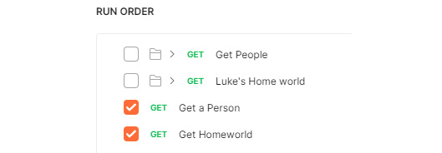
Figure 9 – Collection runner setup
- Once everything is set up correctly, click on the Star Wars API button to run the collection.
You will see that it runs the Get Homeworld request and then it runs the Get a Person request once for each person in the list.
There are some additional things to talk about on the collection runner, which we will cover in Newman assignment, but for now, you can see that you can use the collection runner to easily run multiple tests at once.

Using environments in Postman
Postman environments are a place where you can create and manage variables. You can set up multiple environments for different purposes. Environments are very helpful when you need to share data between requests, and so in this section, I will show you how to use them to manage your variables. You can also manipulate variables in the environment, and so I'll show you how to do that as well so that you can also use Postman environment to help you explore or debug issues. In the first place, let's look at how to manage variables using environments.

Managing environment variables
Creating an environment is easy. Follow these steps to create one:
- Click on the New button and then select the Environment option.
You can give your environment a name; in this case just call it something like SWAPI Env. You can then start creating variables in the environment. Let's use this environment to manage the person_id variable that you are setting in the pre-request script.
- Type person_id in the first field of the VARIABLE column and set the INITIAL VALUE to 1. The following figure shows what that would look like:
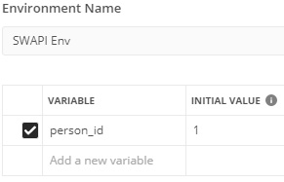
Figure 10 – Create an environment variable
- Save this environment and then close the dialog.
- As shown in the following figure, in the upper right-hand corner of the app, you will see a dropdown. Click on this dropdown and select SWAPI Env from the list:
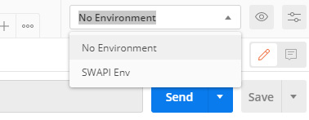
Figure 11 – Select environment
- Now that the environment is active, send the Get a Person request.
This request will set the value of the person_id variable to something new.
- Click on the Environment quick look icon to see what value it has been set to and you should see a panel pop up that looks like this:
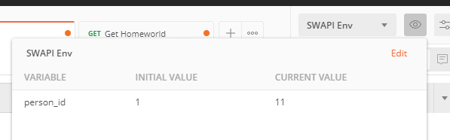
Figure 12 – Environment quick look
Since the ID is selected randomly, you might see a different value than me for the current value, but this shows you already how this can help you manage your data. You now have one spot where you can check on what value is being used for your variable. In addition to using this to manage your environment variable, you can also use it to edit them.

Editing environment variables
One of the many benefits of environments in Postman is the ability to have all your variables in one place so that you can see and understand what is going on. However, there may also be times when you want to edit something in the environment. Perhaps you are trying to debug an issue and need to use a specific value for just one time, or perhaps you are exploring the API and want to try out some specific values. Whatever the use case, there are times you might want to do this, so let's take a look at how that works in Postman. In first place, let's add the residentList variable into the environment as well so that you can manage and edit it. You can add it into the environment with the following steps:
- Click on the Environment quick look icon and then select the Edit option to edit the SWAPI Env environment.
- Add a new variable called residentList and set the initial value of it to be an empty list, that is, with two square brackets like this: [].
- Click on Update and then close the dialog.
- Now go to the Get Homeworld request and on the Tests tab, modify the line where you are setting the variable to use pm.environment.set instead of pm.collectionVariables.set.
This will save the variable value into the environment variable that you just created.
Now that the variable is going to be saved into the environment, we also need to read it out of there.
- Go to the Get a Person request and change the pm.collectionVariables.get line to instead use pm.environment.get.
- Go back to the Get Homeworld request and send it. This will save a list of people into the residentList variable. Once again, open the environment quick look and you should be able to see this list:
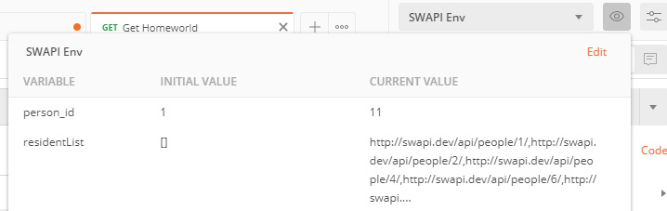
Figure 13 - ResidentList current value
This makes it much easier to manage, but you can also edit the environment variable in here as well. Click on the edit icon that shows up beside the variable when you mouse over, and it will open the current value field for editing. If you wanted to, you could edit this variable. For example, you might remove all entries but one from the list if you were trying to check that the loop works if it only has one item in the list.
Environments allow you to edit variables and give you a lot of control and insight into what is going on. They are a helpful tool for you to manage your data with, and I would recommend using them to manage variables whenever possible.

